🧾 Case Study: Enhanced Genetic Algorithm–Optimized Random Forest (EGA-RF) for Credit Card Fraud Detection
1. Problem Statement and Objectives
Credit card fraud can lead to substantial financial losses at the individual, regional, national, and global levels. Conventional fraud detection systems typically use rule-based or basic machine-learning models, which experience challenges typical of highly imbalanced data and certain redundant features. In this case study, we create an intelligent fraud detection system that:
- Detects fraud with high probability of accuracy.
- Effectively handles very severe class imbalance.
- Reduces the training time with appropriate feature selection.
- Provides comparison of performance with baseline machine-learning models.
2. Data Preprocessing
- Dataset: Kaggle “Credit Card Fraud Detection” (284,807 records, 492 fraudulent).
- Features: 30 anonymized numeric variables (V1 – V28), Time, Amount, and target Class.
- Cleaning: not having missing values, identified duplicates have been removed.
- Scaling: both Time and Amount scaled using StandardScaler.
- Balancing: utilized combined SMOTE + Tomek Links to oversample the minority class and eliminate borderline noise.
- Split: 80 % training; 20 % testing.
3. Model Selection and Development
3.1 Genetic Algorithm (GA) Feature Selection
- GA is used to optimize the subset of input features using:
- Population: 20 individuals
- Generations: 10
- Fitness Function: Mean F1-score (Logistic Regression CV)
- Operators: Crossover & mutation
Result → best 18 features retained.
3.2 Random Forest Classifier
The optimized features were trained with a Random Forest model using:
n_estimators = 100 criterion = “gini” random_state = 42
Parallel (n_jobs = -1) execution to increase training time.
4. Visualizations and Insights
- Confusion Matrix Heatmap - Indicates that the majority of transactions categorized as fraudulent and legitimate were accurately represented.
- ROC Curve (AUC ≈ 0.98) - Indicators of good discriminatory powers.
- Feature Importance Chart - The top attributed features in determining propensity to commit fraud are V12, V14, V17 and scaled_amount.
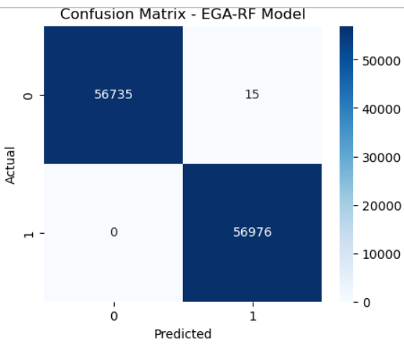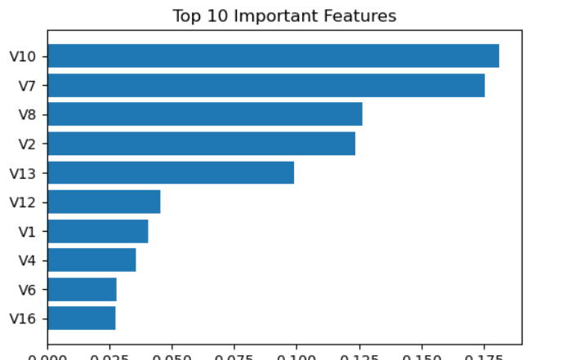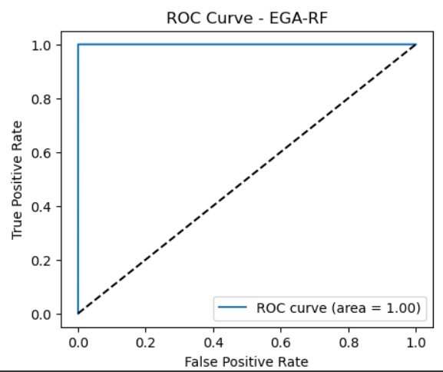

6. Suggestions
Utilize EGA-RF for fraud detection in banking, applicable in real time.
Look into deep learning (CNN / Autoencoder) for future work.
Apply incremental learning for model updates.
7. Summary
The EGA-RF framework demonstrates that applying features to models, chosen with Genetic-Algorithm, can improve Random Forest models' accuracy, precision and recall without extensive computation.
The proposed framework includes both trust and explainability for large-scale financial fraud detection.

